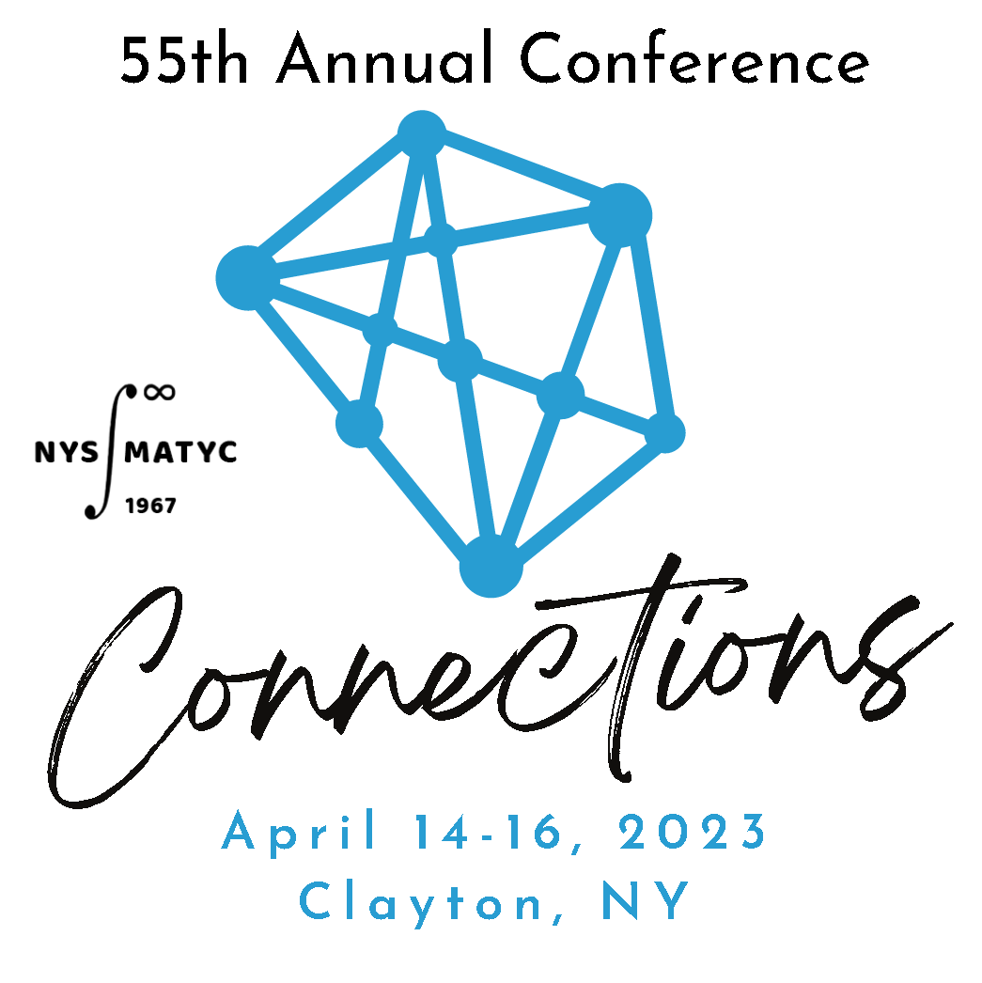
2022-2023 EXECUTIVE BOARD

President  Erin Newton*  Onondaga Community College  President – Elect  Joe Bernat*  Nassau Community College  Past-President  Patty Owens*  Onondaga Community College  Secretary  Chris L. Yuen  SUNY University at Buffalo  Treasurer  Josh Hammond  Jefferson Community College  Scholarship Chair  Elizabeth McGrath  SUNY Broome Community College | Member at Large – Region I  Brian Milleville*  Erie Community College  Member at Large – Region II  Beth Congdon*  SUNY Broome Community College  Member at Large – Region III  Theresa Powers*  Hudson Valley Community College  Member at Large – Region IV  Elizabeth Carris-Swan  Orange County Community College  Professional Development Chair  Alex Atwood*  Suffolk County Community College  Communications Chair  Colleen Stevens*  Onondaga Community College

* Member of the Conference Planning Committee

Math League Abe Mantell Nassau Community College

www.nysmatyc.org

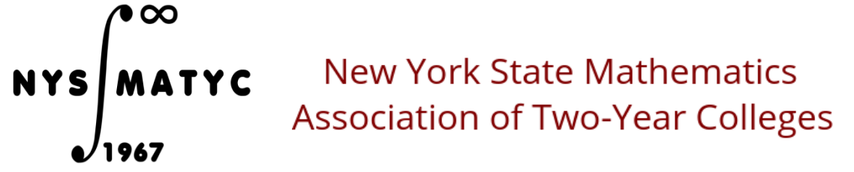

Table of Contents

Description | Page Number
2022-2023 Executive Board | 2
Acknowledgements | 4
Program Summary | 5
Detailed Program | 13
NYSMATYC Business Meeting Agenda | 22
Student Scholarship Report | 23
Outstanding Contributions to Mathematics Education Award Winners | 25
Outstanding Contributions to NYSMATYC Award Winners | 26
Past Presidents of NYSMATYC | 27
Upcoming Conferences | 28

Acknowledgements

The Executive Board of NYSMATYC wishes to thank all presenters, presiders, and attendees for supporting this conference and for being involved in this wonderful organization.

In addition, we would also like to thank the following colleges, companies and persons for supporting this conference, as well as support throughout the year with services and/or sponsorship of events:

Thank you, 1000 Island Harbor Hotel, for hosting our event and especially Lynn Thompson for great help with event facilitation.
Thank you, Abe Mantell, for running the Math League contest.

Thank you, Marc Croteau of Thirsty Fish Graphic Design, for creating a wonderful new website for NYSMATYC.

Thank you, Nassau Community College for printing the conference program and for providing other conference supplies.

A very special thank you to our vendors:
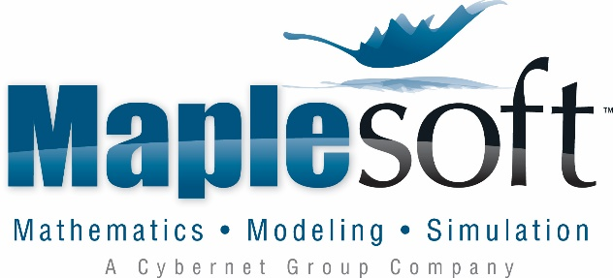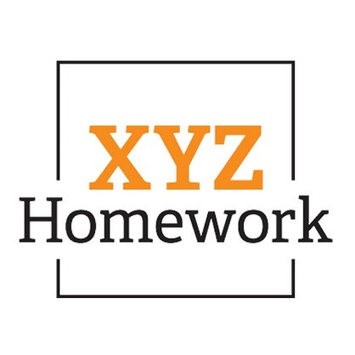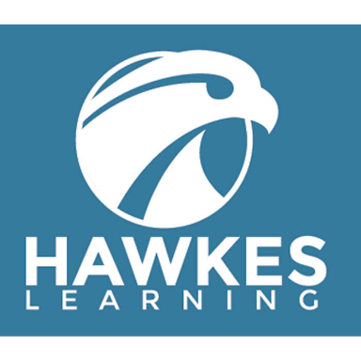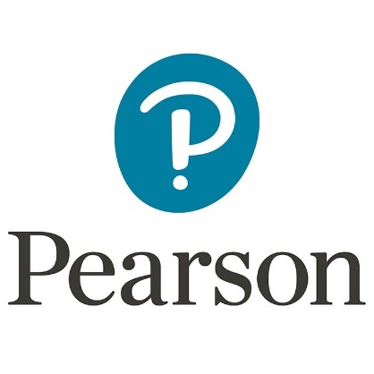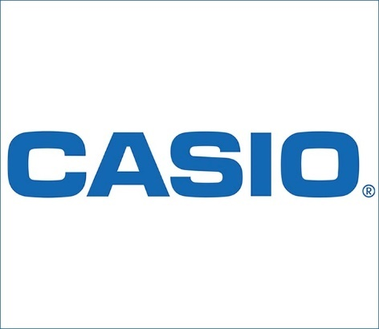
55th Annual NYSMATYC Conference – Program Summary

NYSMATYC Annual Conference
Friday Afternoon/Evening
11:00 AM – 5:00 PM |  | Conference Registration – Hotel Lobby
11:30 – 12:20 |  | Friday Lunch Buffet – Ballroom
Time: | Grindstone |  |  | Calumet
12:25 – 12:55 | 1 |  | Session Cancelled | 2 | Statistics Project  Julie Croteau
1:00 - 2:00 | 3 |  | Building Conceptual Connections with Open Educational Resources  Reva Narasimhan | 4 | Bringing Joy of Mathematics to the Community  Jayashree Hurlburt
2:10 - 3:10 | 5 |  | Learning Activities for Calculus using 3D-Printed Surfaces  Paul Seeburger | 6 | Is Good Good Enough: Making the Most of MyLab Math and Statistics  Ashley Myszka  Pearson
3:20 - 3:30 | Break ---- Prefunction Hallway ---- PLEASE VISIT OUR VENDORS
3:30 – 4:45 | 7 |  | Chat – n – Chew – bring your snacks from the break
5:00 – 6:00 | Executive Board Meeting ---- Piction Boardroom
 | Cocktail Hour – Cash Bar ---- Prefunction Hallway
6:00 – 8:30 | Friday Night Dinner ---- Ballroom  Math League Contest Winners & Scholarship Award Winners Announced!
8:30 - ? | Stay in Ballroom for an informal social and  Puzzles, Puzzles, Puzzles! – led by P. Owens  Join a puzzle team or just hang out! Instruments welcome.

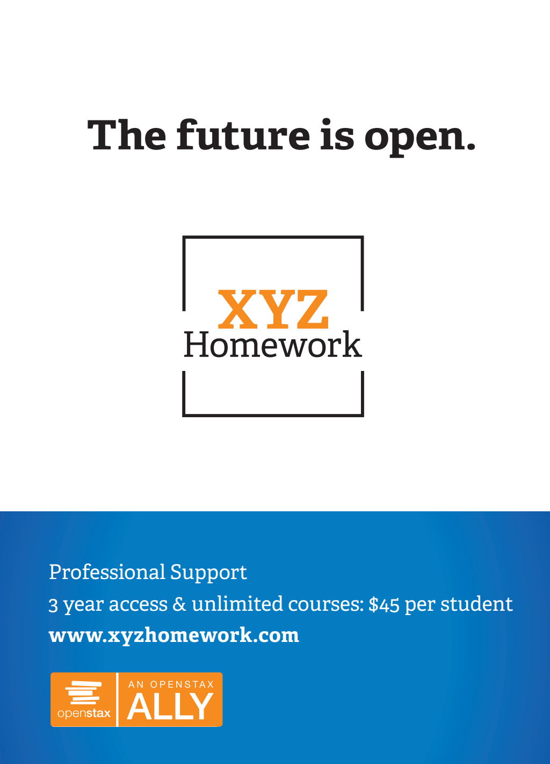
55th Annual NYSMATYC Conference – Program Summary

NYSMATYC Annual Conference
Saturday Morning
6:15 – 7:00 | Estimation Run/Walk ---- Meet in Lobby
7:00 – 7:50 | Saturday Breakfast Buffet - Ballroom
Time: | Grindstone |  | Calumet
8:05 - 9:05 | 8 | Proof of Fermat's Last theorem  Gerald M Smith,  Don Fama | 9 | Teaching Math to Future Elementary Educators… Once Upon a Time Gets a New Happily Ever After  Lindsey Taube
9:15 - 9:45 | 10 | Dissertation Takeaways: What Students of Developmental Mathematics Think  Dr. Jessica Harnly | 11 | SUNY Launch Years Initiative Overview  Heather Ortiz,  Alma Kanic-Franco  Margaret Kaminsky
9:45 - 10:00 | Break ---- Prefunction Hallway ---- PLEASE VISIT OUR VENDORS
10:00 - 11:00 | 12 | Practical applications of LaPlace transforms for analyzing electric circuits  Linda L. Lim, PhD | 13 | Paradoxes in Mathematics  Steven Gottlieb
11:05 – 11:35 | 14 | NYSMATYC Conference – Paradigm and future  Josh Hammond | 15 | XYZ Homework  John Kunkel  Daniel Breuer
11:45 - 12:30 | NYSMATYC Business Meeting ---- Ballroom  All members are encouraged to attend.  AMATYC & NYSMATYC Raffles
12:30 - 1:15 | Saturday Lunch Buffet ---- Ballroom  Estimation Run/Walk Winners Announced!

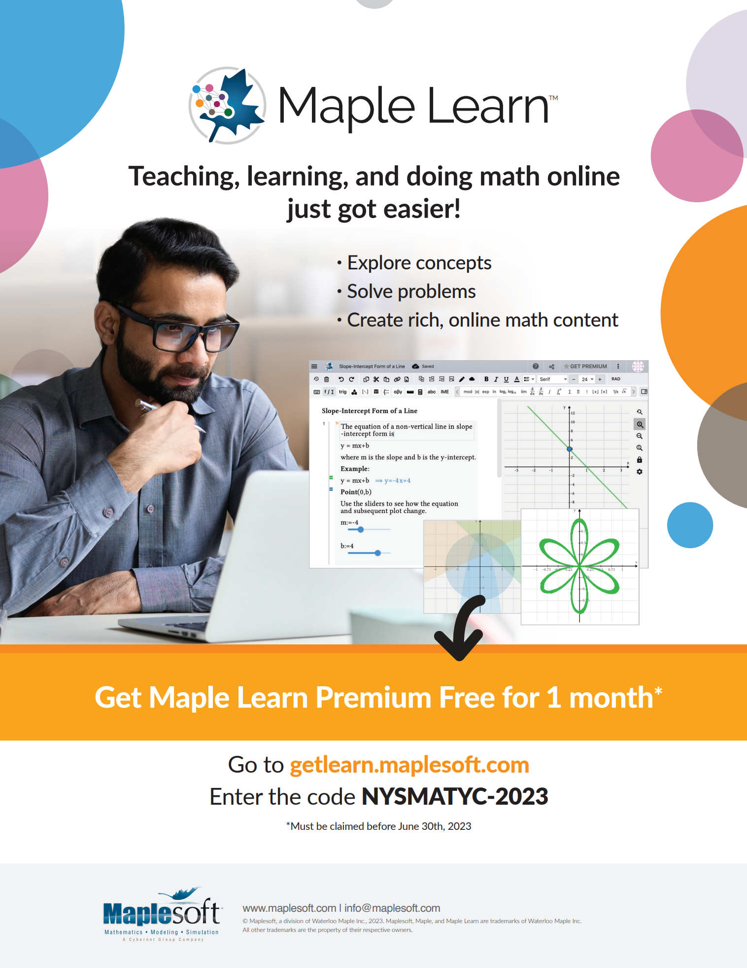
55th Annual NYSMATYC Conference – Program Summary

NYSMATYC Annual Conference
Saturday Afternoon
Time: | Grindstone |  | Calumet
1:20 – 2:20 | 16 | Competency-Based Learning: Fostering a Mastery Mindset  Robert Kahrs  Hawkes | 17 | 1:20 – 2:05  Techniques to get your students to think in their Algebra class  Steven Gottlieb
 |  |  | 18 | 2:05-2:20  Encouraging student success  Stephanie Olstad
2:30 – 3:00 | 19 | Gaining Insight in Calculus and ODE using Interactive GeoGebra Figures  Paul Seeburger | 20 | NYSMATYC Website Overview  Josh Hammond
3:00 – 3:15 | BREAK – Prefunction Hallway - Please Visit Vendors  Leave a note on the NYSMATYC map at the location of your college which explains a Connection you made at this year’s conference.
3:15 – 3:45 | 21 | Review and Discussion of Precalculus Position Statement Draft from AMATYC  Brian Milleville | 22 | Maple Learn: Teaching, learning, and doing math online just got easier!  Max McKee  Maplesoft
3:55 – 4:25 | 23 | Teaching Mathematical Problem Solving with Inductive Modeling, Corner Cases and Asymptotic Behavior  Alex Atwood | 24 | Enticing Recreational Problems  Satyanand Singh

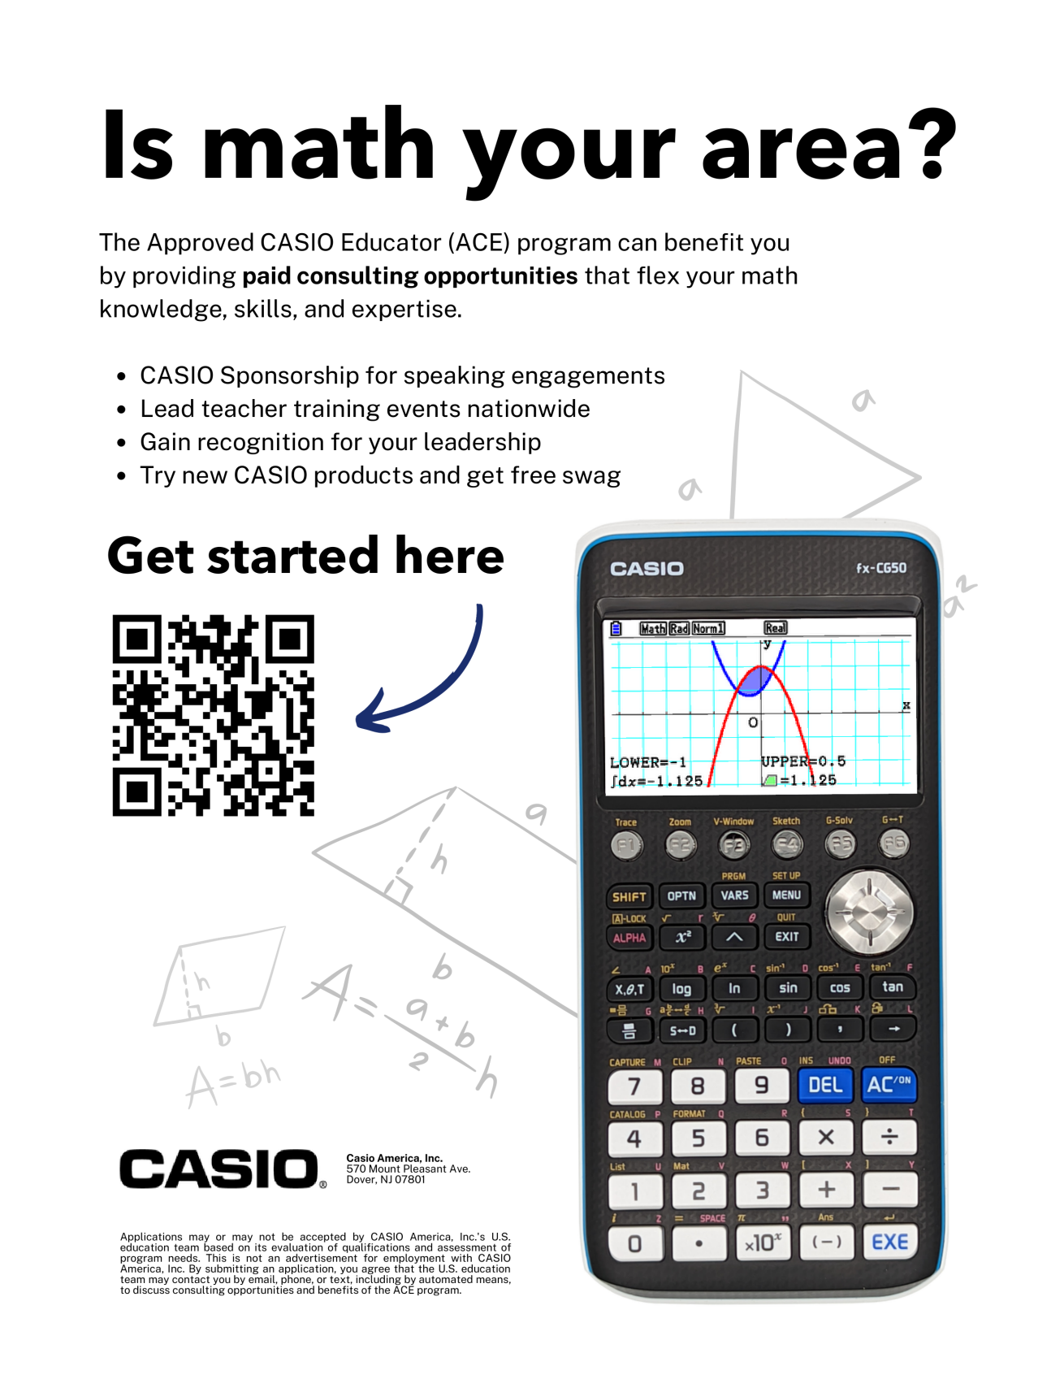
55th Annual NYSMATYC Conference – Program Summary

NYSMATYC Annual Conference
Saturday Evening
Time: | Grindstone |  | Calumet
4:35 - 5:05 | 25 | Discriminants of Quadratics Generalized  Yusuf Gurtas | 26 | Corequisite Math Courses: A Brief History at ECC  Dave Usinski
 | Executive Board Meeting ---- Piction Boardroom
5:15 – 6:15 | Cocktail Hour – Cash Bar ---- Prefunction Hallway
6:15 - ? | Saturday Banquet Dinner---- Ballroom  A Sporting Effort to Maintain Rigor in a Tough Academic Climate will start around 7:00

NYSMATYC Annual Conference
Sunday Morning
8:00 - 8:50 | Sunday Breakfast Buffet ---- Ballroom
Time: | Grindstone |  | Calumet
9:00 – 10:00 | 27 | Grading With Rubrics: Communicating Expectations to Students  Matthew Rogala | 28 | Quick Activities to Start Class  Jayashree Hurlburt
 |  |  | 29 | Flipping the Math Classroom  Theresa Powers
10:00 ... | Please drop off your lanyard and nametag and  submit your conference evaluation form.  Safe travels home!

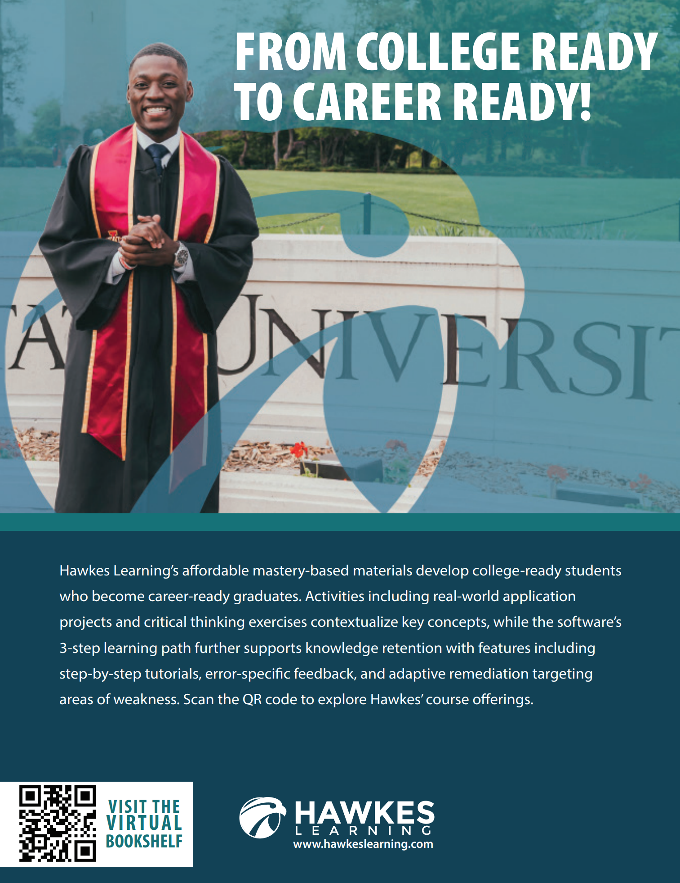
55th Annual NYSMATYC Conference Detailed Program
Time and session number | Description and location
Friday April 14th, 2023
11:30 – 12:20 | Friday Lunch Buffet – Ballroom
12:25 – 12:55 | Sessions 1 and 2 Friday, April 14th
1  Grindstone | Title: Cancelled  Presenter: Cancelled  Presider:
2  Calumet | Title: Statistics Project  Presenter: Julie Croteau  Presider: Alex Atwood  In Elementary Statistics, the presenter has found a final project to be one of the most worthwhile activities of the course. Julie will share her project assignment as well as some sample student posters. Students don't always get mind-blowing results, but the statistical understanding really develops in doing the project.
1:00 – 2:00 | Sessions 3 and 4 Friday, April 14th
3  Grindstone | Title: Building Conceptual Connections with Open Educational Resources  Presenter: Reva Narasimhan  Presider: Russ Penner  Leveraging widely available graphing apps and OER textbooks, this presentation will illustrate how a college algebra course for business majors is brought to life through engaging models and visualization, with OneNote as the content platform for activities and assessments.
4  Calumet | Title: Bringing Joy of Mathematics to the Community  Presenter: Jayashree Hurlburt  Presider: Ernie Danforth  In this session, the speaker will discuss how the Math Department at Corning Community College has been forming "connections" with the local community at various levels: Middle School girls, High School students and Corning Community College students and employees. Details of various activities will be given that are done at each level.

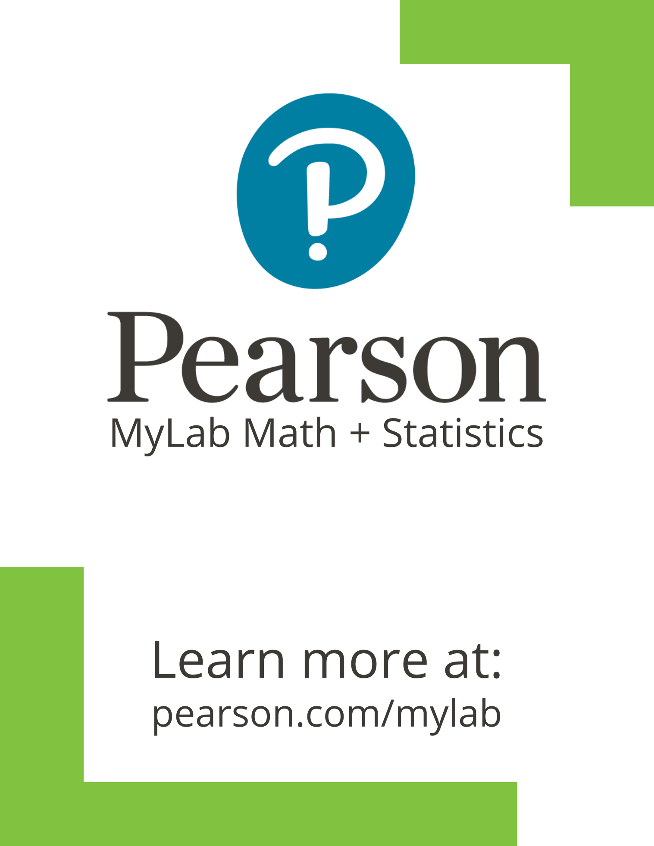
Friday April 14th, 2023
2:10 – 3:10 | Sessions 5 and 6 Friday, April 14th
5  Grindstone | Title: Learning Activities for Calculus using 3D-Printed Surfaces  Presenter: Paul Seeburger  Presider: Elizabeth McGrath  Come experience learning activities using 3D-printed surfaces to explore Shell and Washer methods. As time allows we may also complete a hands-on activity to explore contour plots, directional derivatives, or constrained optimization. The PDFs and STL files are provided so you can use the activities with your own classes!
6  Calumet | Title: Is Good Good Enough: Making the Most of MyLab Math and Statistics  Presenter: Ashley Myszka - Pearson  Presider: Erin Newton  In this session we will talk through our all-new resources in MyLab Math and Statistics that have been studied to improve pass rates, outcomes, and student/instructor success. In this session we will cover our personalization resources, student engagement tools, and our brand-new Interactive Courses for Statistics and Calculus that were just released. Ashley Myszka has been with Pearson for 8 years and is a Math and Statistics Specialist for the Northeast Region.
3:20 - 3:30 | Break ---- Prefunction Hallway ---- PLEASE VISIT OUR VENDORS
3:30 – 4:45  7  Ballroom | Chat - ‘N’ - Chew Friday, April 14th  Organizers: Brian Milleville  Attendees rotate through various tables throughout the session. Each table has a facilitator and a particular topic so ideas can be shared and discussed surrounding that topic. Topics include co-requisites, concurrent enrollment, placement policies, OERs, pathways, alternative instructional modalities, technology tools for instruction/assessment, AMATYC Impact, and what we want NYSMATYC to be. Bring some snacks from the break so that you can chew while you chat!
5:00 – 6:00 | Executive Board Meeting in the Piction Boardroom–NYSMATYC Board
Cocktail Hour in the Prefunction Hallway (Cash Bar) - for everyone!
Connect with colleagues from around the state while enjoying a cocktail.
6:00 – 8:30 | Friday Night Dinner  Enjoy the Friday night dinner buffet. After dinner, Abe Mantell (Math League Coordinator) will announce winners of the Math League Contest. Then Elizabeth McGrath (Scholarship Chair) will present the NYSMATYC Scholarship Awards to winning students.
8:30 - ? | Puzzles, Puzzles, Puzzles Friday, April 14th  Organizer: Patty Owens  With this being our first face-to-face conference since 2019, we had to bring back “Puzzles, Puzzles, Puzzles” this year. Teams of four will compete in this year’s puzzle contest. Create your own team ahead of time, or join with others at the session.  If you just want to hang out with other math folks, that is fine too!
Saturday April 15th, 2023
6:00 – 7:00 | Gerry Leiblich Memorial Estimation Run/Walk ---- Meet in Hotel Lobby  Organizer: Chris Yuen  The Estimation Run is a tradition at NYSMATYC. All you have to do is show up in the hotel lobby ready at 6:00 AM ready to go outside for a beautiful run or walk around Clayton. Be sure to leave your smart watches and phones behind! Chris will collect your choice of route/distance (typically 1 or 2 mile choices) and your estimate of how long it will take you to finish. The goal is to see who gets closest to their estimated time.
7:00 – 7:50 | Saturday Breakfast Buffet – Ballroom
8:05 – 9:05 | Sessions 8 and 9 Saturday, April 15th
8  Grindstone | Title: Proof of Fermat's Last theorem  Presenter: Gerald Smith and Don Farma  Presider: Satyanand Singh  Two independent proofs of Fermat's Last Theorem by retired Professors Gerald Smith and Don Fama, formerly with Cayuga CC. This is an example of retired professors finding an interesting problem in their discipline and using their ("extended") free time to solve it.
9  Calumet | Title: Teaching Math to Future Elementary Educators… Once Upon a Time Gets a New Happily Ever After  Presenter: Lindsey Taube  Presider: Elizabeth McGrath  Looking to share ideas about discovering greater engagement and math connection in math elementary education classes? Join Lindsey as she shares how she revamped her courses to do just that. Find out how her once upon a time story found a new happily ever after ending.
9:15 – 9:45 | Sessions 10 and 11 Saturday, April 15th
10  Grindstone | Title: Dissertation Takeaways: What Students of Developmental Mathematics Think  Presenter: Dr. Jessica Harnly  Presider: Suzanne Zybert  Limited research has investigated the mathematical perspectives of community college students in developmental math. This presentation shares findings from a dissertation study that explored the impact of incorporating learning and study skills into Quantway classes (using LASSI) and investigated how the students described their learning experiences in math class.
11  Calumet | Title: SUNY Launch Years Initiative Overview  Presenter: Heather Ortiz, Alma Kanic-Franco, and Margaret Kaminsky  Presider: Beth Congdon  We plan on giving an overview of Launch Years Initiative from national perspective by our Dana Consultant, from SUNY perspective, and faculty engagement.
9:45 – 10:00 | Break ---- Prefunction Hallway  Please visit our supporting vendors – remember that vendor fees help fund our student scholarship awards!
Saturday April 15th, 2023
10:00 – 11:00 | Sessions 12 and 13 Saturday, April 15th
12  Grindstone | Title: Practical applications of LaPlace transforms for analyzing electric circuits  Presenter: Linda L. Lim, PhD  Presider: Paul Seeburger  Dr. Lim will demonstrate how LaPlace transforms can be used to convert time-varying electric circuits into an s-domain form, which allows the user/student to avoid higher-order differential equations when analyzing the circuit, and instead makes the calculations algebraic. This can be useful for teachers of differential equations/higher calculus when students ask about a practical purpose for mathematical transforms.
13  Calumet | Title: Paradoxes in Mathematics  Presenter: Steven Gottlieb  Presider: Beth Congdon  In this talk we will look at a number of paradoxes in mathematics. Expect to leave the room shocked!
11:05 – 11:35 | Sessions 14 and 15 Saturday, April 15th
14  Grindstone | Title: NYSMATYC Conference - Paradigm  Presenter: Josh Hammond  Presider: Chris Yuen  This presentation will look at our current conference modality, schedule, and traditions. Other potential conference models will be shared. The presenter and executive board are encouraging audience participation and feedback.
15  Calumet | Title: XYZ Homework  Presenter: John Kunkel and Daniel Breuer – XYZ Homework  Presider: Patty Owens
11:45 – 12:30 | NYSMATYC Business Meeting ---- Ballroom  All members are encouraged to attend. An agenda can be found on page 22  AMATYC & NYSMATYC Raffles…some great prizes await!
12:30 – 1:15 | Saturday Lunch Buffet ---- Ballroom  Estimation Run/Walk Winners Announced!
1:20 – 2:20 | Sessions 16, 17, and 18 Saturday, April 15th
16  Grindstone | Title: Competency-Based Learning: Fostering a Mastery Mindset  Presenter: Robert Kahrs – Hawkes Learning  Presider: Beth Congdon  Discover how a mastery-based, 3-step approach to learning fosters genuine competency by removing learning aids, adapting to individual proficiencies, and providing immediate, corrective remediation. Consider a competency-based learning strategy to set goals for students and give them the flexibility and resources to succeed. Win one of three $25 gift cards!

Saturday April 15th, 2023
17  1:20 – 2:05  Calumet | Title: Techniques to get your students to think in their Algebra class  Presenter: Steven Gottlieb  Presider: Mary Crawford-Mohat  In this presentation we will talk about ways to get your students to think mathematically.
18  2:05 – 2:20  Calumet | Title: Encouraging student success  Presenter: Stephanie Olstad  Presider: Mary Crawford-Mohat  This session involves two different methods used to help increase student success--students creating "cheat sheets," and students writing letters to future students on how to be successful in the course.
2:30 – 3:00 | Sessions 19 and 20 Saturday, April 15th
19  Grindstone | Title: Gaining Insight in Calculus and ODE using Interactive GeoGebra Figures  Presenter: Paul Seeburger  Presider: Jayashree Hurlburt  Visual exploration adds significant meaning and promotes a more intuitive understanding of many topics in calculus and differential equations. Come see interactive GeoGebra figures that explore area functions, the motion of a spring (with or without damping and forcing), bifurcation, etc. Useful as classroom demonstrations or for independent student learning.
20  Calumet | Title: NYSMATYC Website Overview  Presenter: Josh Hammond  Presider: Julie Croteau  Come see the features of our new website. The presenter and the executive board are looking forward to your feedback.
3:00 – 3:15 | BREAK – Prefunction Hallway - Please Visit Vendors  Leave a note on the NYSMATYC map at the location of your college which explains a “Connection” you made at this year’s conference.
3:15 – 3:45 | Sessions 21 and 22 Saturday, April 15th
21  Grindstone | Title: Review and Discussion of Precalculus Position Statement Draft from AMATYC  Presenter: Brian Milleville  Presider: Dave Usinski  The Math Intensive Academic Network of AMATYC has a draft position paper on Precalculus. We will review the draft, discuss, and provide feedback.

Saturday April 15th, 2023
22  3:15 – 3:45  Calumet | Title: Maple Learn: Teaching, learning, and doing math online just got easier!  Presenter: Max McKee – Maplesoft  Presider: Chris Yuen  From disruptive advancements in technology to the sudden increase in remote learning and working, how we teach, learn, and do math is evolving rapidly. In response to this shifting landscape, Maplesoft created Maple Learn to help schools amplify their mathematics teaching excellence and provide engaging, interactive experiences for their students. In this presentation, you’ll discover how Maple Learn provides a flexible interactive environment for solving problems, a great platform for conceptual learning, and incredibly simple content development and deployment solutions. You’ll also discover low-effort ways to take advantage of Maple Learn in your classroom immediately, despite your busy schedule.
3:55 – 4:25 | Sessions 23 and 24 Saturday, April 15th
23  Grindstone | Title: Teaching Mathematical Problem Solving with Inductive Modeling, Corner Cases and Asymptotic Behavior  Presenter: Alex Atwood  Presider: Ryan McCann  Inductive Mathematical Modeling from simple cases, analyzing corner cases, and examining asymptotic behavior of models can enable students to solve mathematical problems in surprising ways.
24  Calumet | Title: Enticing Recreational Problems  Presenter: Satyanand Singh  Presider: Mary Crawford-Mohat  In this presentation, a set of problems with a geometric twist are illustrated. They appeal to both students and faculty. These problems highlight the allure of mathematics, enhance learning, and are readily accessible to engage high school and undergraduate students as well as connect with their regular course work.
4:35 - 5:05 | Sessions 25 and 26 Saturday, April 15th
25  Grindstone | Title: Discriminants of Quadratics Generalized  Presenter: Yusuf Gurtas  Presider: Russ Penner  Discriminants of quadratics can be generalized to higher degree polynomials using their leading three terms to gain partial information about the nature of their roots. Special emphasis will be given to cubic polynomials in classroom teaching setting.
26  Calumet | Title: Corequisite Math Courses: A Brief History at Erie Community College  Presenter: Dave Usinski  Presider: Suzanne Zybert  This presentation will provide a brief overview of corequisite math courses at ECC. Additionally, the presenter will provide a detailed analysis of student success in corequisite math courses using several semesters of data. Finally, the presenter will invite participants to discuss corequisite math courses at their institutions.
Executive Board Meeting – Piction Boardroom
The newly elected Executive Board for 2023-2024 meets at this time.
Keynote Saturday April 15th, 2023
5:15 – 6:15 | Cocktail Hour – Cash Bar ---- Prefunction Hallway
6:15 – 8:30 | Saturday April 15th Banquet Dinner ---- Ballroom
Around 7:00 | Keynote Presentation by Dr. John Eric Goff --- Ballroom
NYSMATYC is pleased to announce that world-renowned sports physicist Dr. John Eric Goff will be giving the keynote at this year’s annual conference. The presentation is titled: A Sporting Effort to Maintain Rigor in a Tough Academic Climate.

Abstract: Teaching and researching at a small university is accompanied by a myriad of struggles. Shrinking department budgets, ever expanding administrative structures, growing number of ill-prepared and unmotivated students, and pressure to fill classrooms and keep them filled are merely some of the struggles we face.

Dr. Goff will discuss how he has navigated through a tough academic landscape for more than 20 years. Part of that navigation has been using his research area of sports physics to arouse in some students a real passion for physics and research. His work with World Cup soccer balls and the Tour de France, for example, has stoked excitement in students. Given all of the genuine reasons to be pessimistic about the current state of affairs at colleges and universities that do not sit near the top of the rankings, he hopes to offer a few ideas that might help inject optimism into academic departments.

Biography for John Eric Goff, PhD:
Dr. John Eric Goff, a professor of physics at the University of Lynchburg, has researched many areas of sports physics including the air friction of the designs of World Cup soccer balls, the friction between shoes and hard courts in tennis, and modeling for contestants of the Tour de France. Goff has authored two books: The physics of Krav Maga and Gold Medal Physics and has co-authored dozens of research articles on a variety of sports physics applications.

Goff has also been a guest on numerous episodes of Star Talk Radio with Neil deGrasse Tyson, most recently to discuss the physics of the World Cup.
Additionally, he has done physics commentary as part of TuneIn’s NFL coverage in 2017 and has contributed to articles in TIME, The New York Times, Business Insider, The Wall Street Journal, WIRED, BBC and more.

A link to his CV and other information can be found on the NYSMATYC.org website.
Sunday April 15th, 2023
8:00 - 8:50 | Sunday Breakfast Buffet ---- Ballroom
9:00 – 10:00 | Sessions 27, 28 and 29 Saturday, April 15th
27  Grindstone | Title: Grading With Rubrics: Communicating Expectations to Students  Presenter: Matthew Rogala  Presider: Lindsey Taube  Grading rubrics are a common tool in the teacher's toolkit but can be tricky to implement in math classes. In this presentation, a sample general grading rubric will be presented, along with some ideas for instructors to use such rubrics to effectively communicate expectations and progress to students.
28  9:00 – 9:30  Calumet | Title: Quick Activities to Start Class  Presenter: Jayashree Hurlburt  Presider: Erin Newton  In this session, the speaker will share some activities that she does during the first five minutes (or less) of class (Quantitiative Reasoning, Precalculus, Calculus III and Linear Algebra). This is to grab the students' attention and get them ready for the day's lesson. The audience will be invited to participate in some of the activities.
29  9:30 – 10:00  Calumet | Title: Flipping the Math Classroom  Presenter: Theresa Powers  Presider: Erin Newton  Have you ever thought about flipping the math classroom? Have you ever tried it? In this presentation, Theresa will share what she has done this semester with the flipped classroom and how it has been working so far. She would then love for you to share your thoughts and ideas as well.
10:00 ... | Please drop off your lanyards and name tags and have a safe trip home.  See you next year!!
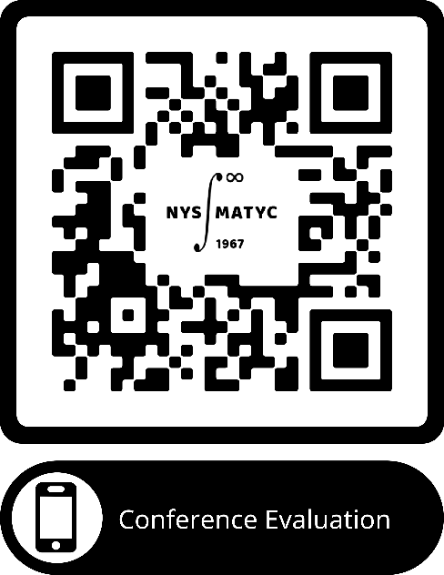

Please fill out our conference evaluation form by scanning this QR code from any web-enabled device:

2023 NYSMATYC Business Meeting Agenda
Saturday April 15, 2023

- President’s Report – Erin Newton
- Approval of Minutes of April 09, 2022 – Chris Yuen
- Treasurer’s Report – Josh Hammond
- Elections Report – Patty Owens
- Committee Reports
  - Audit – Regional Members at Large
  - Awards – Patty Owens
  - Communications – Colleen Stevens
  - Professional Development – Alex Atwood
  - Scholarship – Liz McGrath
  - Region Members at Large – Brian Milleville (I), Beth Congdon (II), Theresa Powers (III), Liz Carris-Swan (IV)
- Other Business
  - Vote on Constitution change from last year’s meeting
    - A change in membership types that will align with the new website. The two non-voting types, retired faculty membership and adjunct faculty membership will become (non-voting) associate members. Regular members remain unchanged as voting members.
  - New Website Update – Josh Hammond
  - NYSMATYC Representation to Other Organizations
    - AMATYC – George Hurlburt
    - AMTNYS – TBA
    - NCTM – TBA
    - MAA Metro – TBA
    - MAA Seaway – TBA
  - 2023 Conference Report – Joe Bernat
  - Math League Report – Abe Mantell
- New Business
  - Appointments – Joe Bernat
  - Upcoming Conferences – Patty Owens
    - 2024 – April 12-14, Best Western Plus, Kingston – Region IV
- Raffles
- Adjournment
2022-2023 NYSMATYC Student Scholarship Report:

Dan Dodway Scholarship

Rubi Larancuent from CUNY Bronx Community College

NYSMATYC Award for Excellence in Mathematics

Edward Celiz from Orange County Community College

NYSMATYC Award for Excellence in Mathematics

Jacquelyn Osburn from Corning Community College

NYSMATYC Award for Excellence in Mathematics

Stiviyan Yavorov Dragiev from Orange County Community College

NYSMATYC Award for Excellence in Mathematics

Eisha Sarmad from Rockland Community College

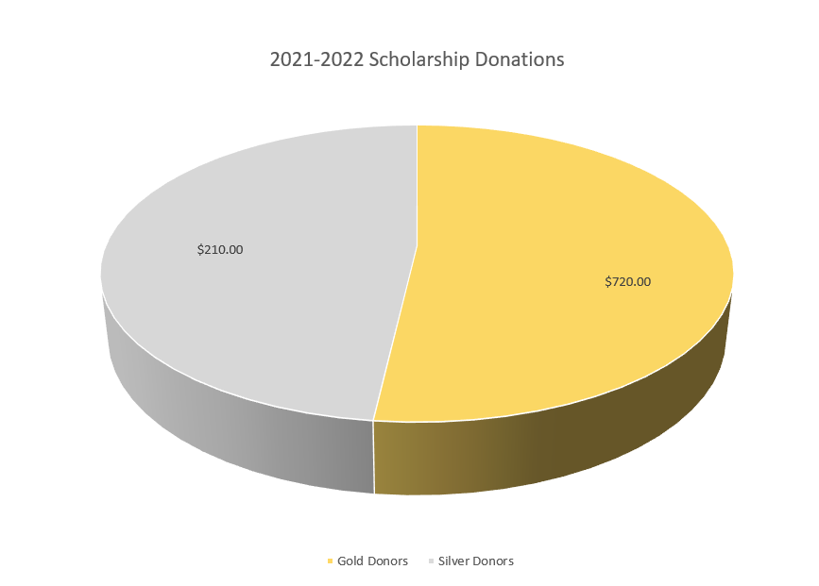
Gold Donors Silver Donors
Tim Grosse Elizabeth Carris-Swan
Daniel Groom Abe Mantell
Jay Hurlburt Richard Moscatelli
George Hurlburt Michelle Tubbs
We would like to thank all of our scholarship donors for their continued support of the mission of NYSMATYC.
Scholarship Awards since 1978

OUTSTANDING CONTRIBUTIONS
TO MATHEMATICS EDUCATION
AWARD WINNERS

1972 | George Pedwick | Executive Director of CU
 | James Eastham | Queensborough CC
1973 | Erwin Just | Bronx Community College
1974 | Norm Schaumberger | Bronx Community College
1975 | Leon Ablon | Staten Island Community College
 | Helen Siner | Staten Island Community College
 | Calvin Lathan | Monroe Community College
1976 | Lawrence Trivieri | Mohawk Valley Community College
1977 | Herb Gross | Corning Community College
1978 | Allyn Washington | Corning Community College
1979 | Peter Lindstrom | Genesee Community College
1980 | James Baldwin | Nassau Community College
 | Sheldon Gordon | Suffolk County Community College
1981 | Warren Page | New York City Technical College
1982 | Gerald Lieblich | Bronx Community College
1983 | George Miller | Nassau Community College
 | Geoffrey Akst | Manhattan Community College
1986 | Allen Angel | Monroe Community College
1987 | Don Cohen | SUNY Cobleskill
1990 | Joseph Browne | Onondaga Community College
1991 | Richard Schwartz | College of Staten Island
1992 | Mona Fabricant | Queensborough Community College
1994 | Susan Forman | Bronx Community College
1995 | Sadie Bragg | Borough of Manhattan Community College
1996 | Rick Patrick | Adirondack Community College
1997 | Philip Cheifetz | Nassau Community College
1999 | Rose Tan | Westchester Community College
2000 | James K. Baker | Jefferson Community College
2005 | Dona Boccio | Queensborough Community College
2011 | Ernie Danforth | Corning Community College
2012 | Roy Cameron | SUNY Cobleskill
2015 | Paul Seeburger | Monroe Community College

OUTSTANDING CONTRIBUTIONS
TO NYSMATYC
AWARD WINNERS

1971 | Frank Avenoso, | Nassau Community College
1972 | Michael Sentlowitz, | Nassau Community College
1973 | Sam McInroy, | Corning Community College
1985 | Helen Seiner, | The College of Staten Island
1988 | Paul Earl, | Broome Community College
1989 | Roy Cameron, | SUNY Cobleskill
1990 | John Impagliazzo, | Hofstra University
1991 | Karl Klee, | Jamestown Community College
2001 | Don Willner, | Mohawk Valley Community College
2002 | Maryann Justinger | Erie Community College
2003 | Ernie Danforth, | Corning Community College
2004 | Kate Danforth, | Corning Community College
2005 | John Vadney, | Fulton-Montgomery Community College
2006 | Ken Mead, | Genesee Community College
2007 | Mary Beth Orrange, | Erie Community College
2009 | Ray LaBounty, | Corning Community College
2010 | Abe Mantell, | Nassau Community College
2016 | Herbert Gross, | Corning Community College
2018 | Richard Moscatelli, | Nassau Community College
2019 | George Hurlburt, | Corning Community College

PAST PRESIDENTS OF NYSMATYC

1967–1968 Herbert Gross | 1968–1969 John Vadney
1969–1970 John Vadney | 1970–1971 Raymond McCartney
1971–1972 John Walter | 1972–1973 Harold Hackett
1973–1974 Donald Cohen | 1974–1975 Allyn Washington
1975–1976 Sam McInroy | 1976–1977 Robert Burghardt
1977–1978 Paul Earl | 1978–1979 Allen Angel
1979–1980 Gerald Lieblich | 1980–1981 Lawrence Trivieri
1981–1982 Bruce Haney | 1982–1983 Roy Cameron
1983–1984 Karl Klee | 1984–1985 Carol Kublin
1985–1986 Susan Forman | 1986–1987 Gerald Smith
1987–1988 Joseph Browne | 1988–1989 Dan Dodway
1989–1990 Ernest Danforth | 1990–1991 Sadie Bragg
1991–1992 Leonard Malinowski | 1992–1993 Richard Rupprecht
1993–1994 Judy Cain | 1994–1995 Joan Page
1995–1996 Frank Mandrey | 1996–1997 Kate Danforth
1997–1998 Maryann Justinger | 1998–1999 Rick Patrick
1999–2000 Jane Tanner | 2000–2001 Dona Boccio
2001–2002 Beverly Broomell | 2002–2003 Maureen O’Grady
2003–2004 MaryBeth Orrange | 2004–2005 Jodi Cotten
2005–2006 Jerilyn Fairman | 2006-2007 Abe Mantell
2007-2008 George Hurlburt | 2008-2009 Sue Kutryb
2009-2010 Emad Alfar | 2010-2011 Tim Grosse
2011-2012 Ray LaBounty | 2012-2013 Abe Mantell
2013-2014 Sophia Georgiakaki | 2014-2015 Russ Penner
2015-2016 Larry Danforth | 2016-2017 Josh Hammond
2017-2018 George Hurlburt | 2018-2019 Chris Kemp
2019-2020 Julie Croteau | 2020-2021 Jayashree Hurlburt
2021-2022 Patty Owens | 2022-2023 Erin Newton

UPCOMING CONFERENCES

See you at next year’s NYSMATYC
Annual Conference in Kingston, NY!
April 12 – 14, 2024

MAA Seaway will be at the University of Waterloo, Ontario, Canada May 5-6.

Metro NY Section of the MAA Annual Meeting will be held on April 29 (Saturday) at Pace University in Manhattan.
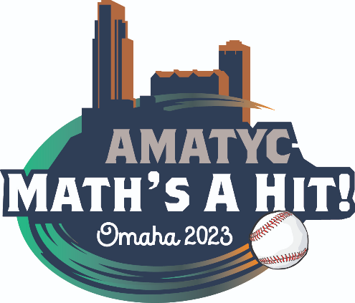

49th AMATYC Annual Conference

Omaha, Nebraska
November 9 – 12, 2023

Opportunity for NSF-funded Workshop:
Seeking teams from Two-Year Colleges (TYCs) to apply for a new NSF-funded workshop series, "Exploring Academic Unit-Level Change at Two-Year Colleges" https://nsf.gov/awardsearch/showAward?AWD_ID=2230271&HistoricalAwards=false
(#2230271)! Please pass this announcement on.

This opportunity is for TYC faculty, staff, and administrators who want to enhance undergraduate education in a STEM-related academic department or unit. Participating TYC teams will attend a series of four workshops from August 2023 to August 2024.

Together with other STEM educators, administrators, and support staff, your team will analyze and identify approaches to change that can support STEM-related units in TYCs, and carry out a local change-related project. In addition to these activities, program outcomes include enhancing your individual skills in supporting educational change and publishing a collectively authored paper about workshop findings. Your team will be among up to fifteen teams from different TYCs in the US to participate, and participating individuals will be supported with a stipend.

For a detailed invitation and how to apply, please visit:
https://www.colorado.edu/csl/workshop-exploring-academic-unit-change-two-year-colleges
Distributed on behalf of: Doug Ensley, Director of MAA OPEN Math

